September 2023 Word and Image,
A New Gallery available for viewing at St. Paul’s Monastery

Word and Image features images from Sister Jacqueline Leiter, OSB juxtaposed with Haiku poetry by Sister Rose Alice Althoff and Sister Carol Rennie. This gallery is now up through DATE. We look forward to seeing you! Just contact the Monastery main number to arrange a visit. 651-777-8181

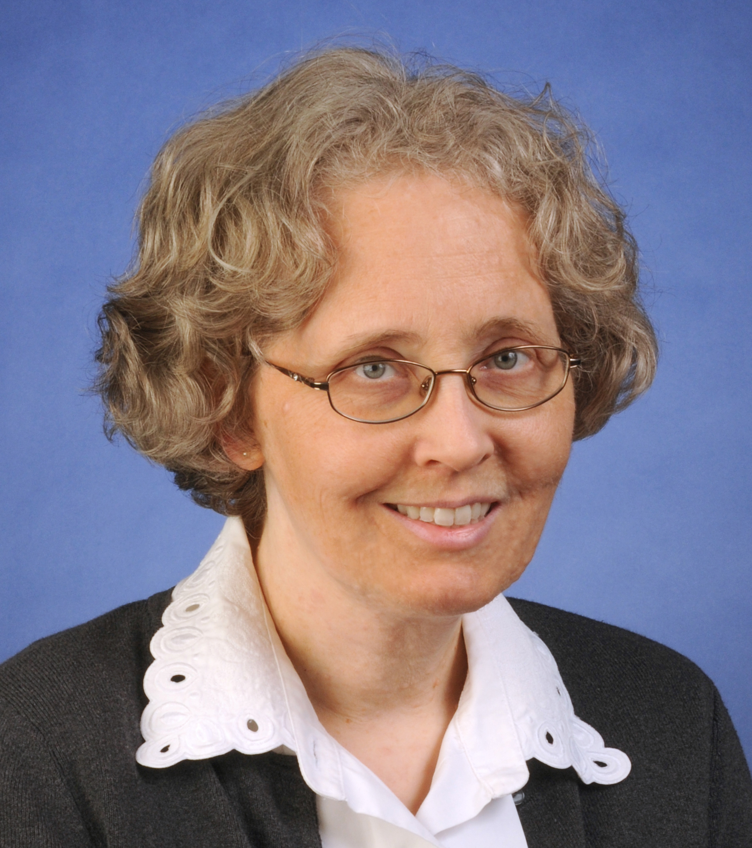

Artist Sister Jacqueline Leiter, OSB

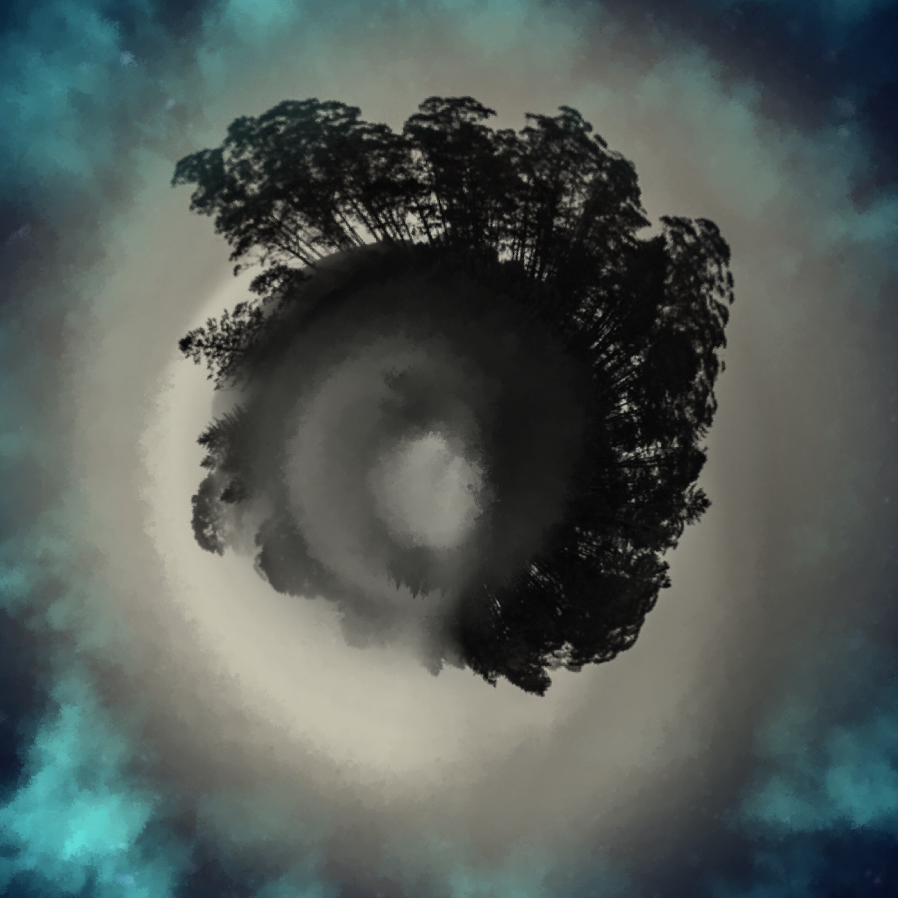
Art is a way to add beauty to the world and respond to God’s creation “so that in all things, God may be glorified” (RB 57:9, 1 Peter 4:11). Art and the natural world invite us to encounter the holy in our lives and to open the eyes and ears of our hearts. God’s voice may come to us in a still, small voice when we do not expect it. My photography seeks to connect with this voice. Gazing on the beauty of the world, of land, sky, water, and on the beauty of each other becomes a way to encounter the holy in our lives and invites us to open our hearts to something new
Gethsemane by Sister Jacqueline Leiter
bring who you are
shedding layers of pretense
true humility – Sister Rose Alice Althoff

Through my work I seek to represent the experience of listening to the voice we hear within. This voice may encourage and strengthen us; it may challenge us and surprise us. My hope is that my images will help each person to find this place within and hear this voice within the ear of the heart.
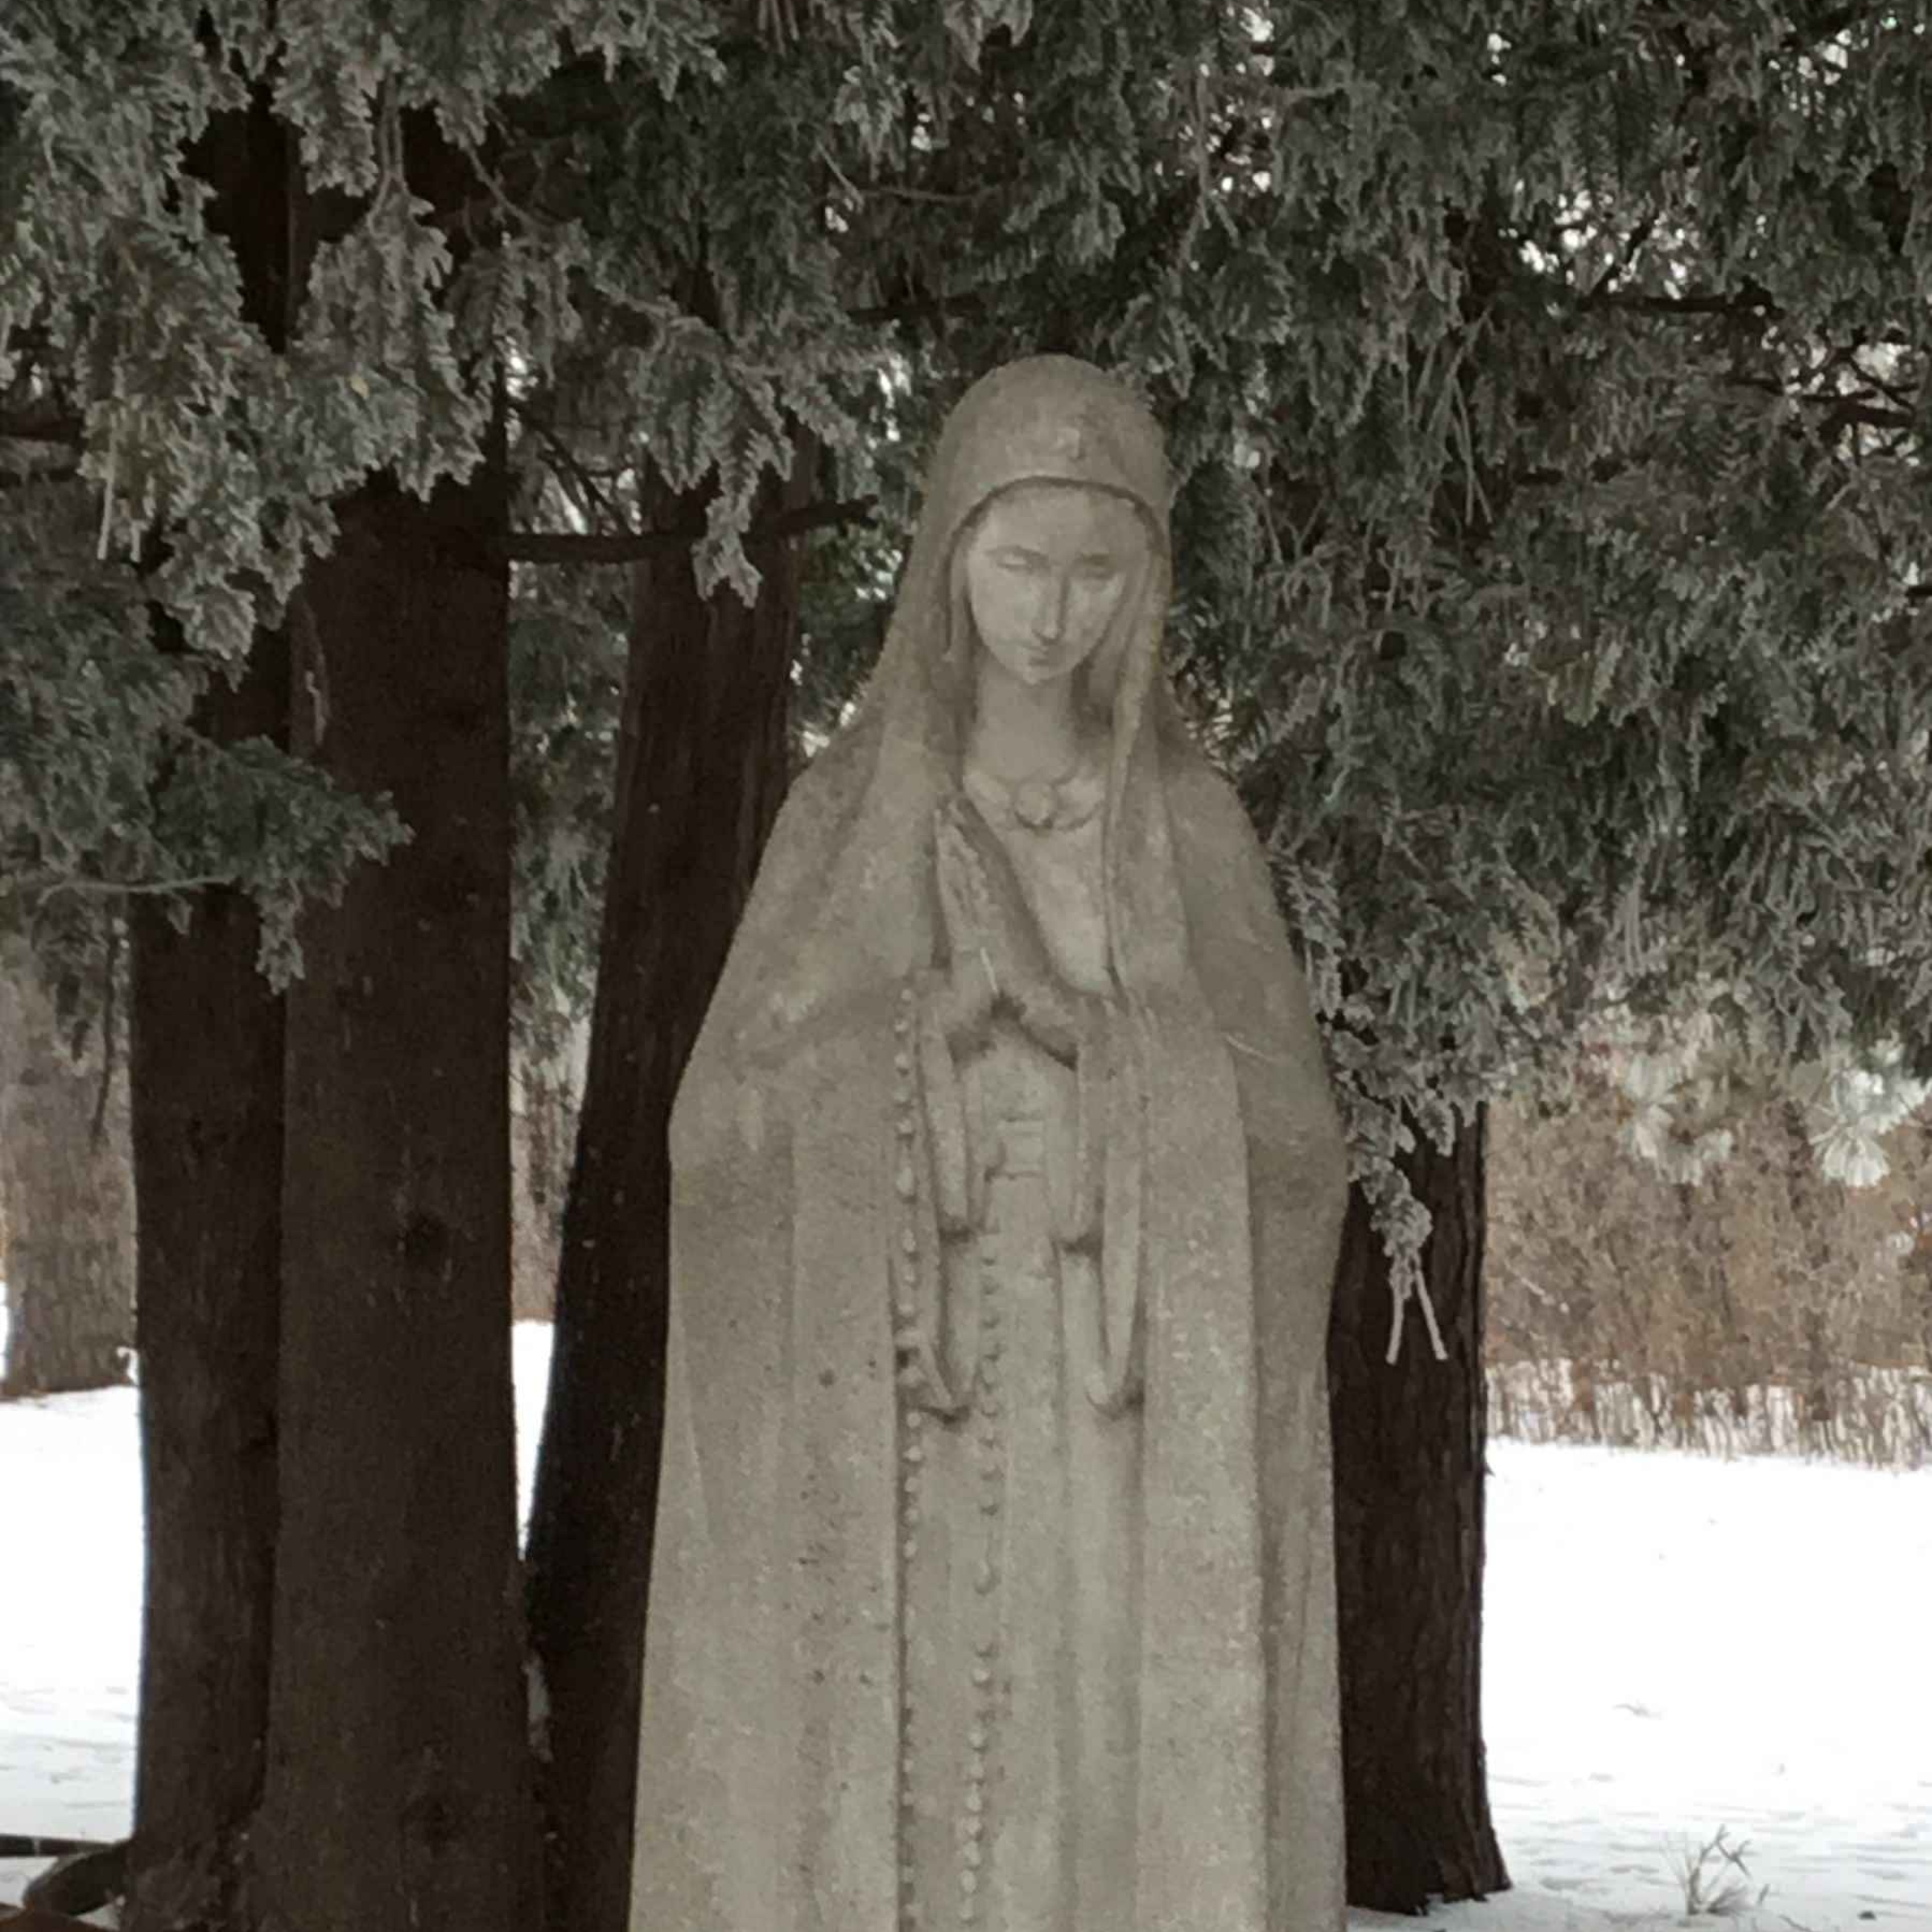
Magnificat by Sister Jacqueline Leiter.
Praying is gazing
My soul magnifies the LordHoly is Your Name -Sister Carole Rennie

