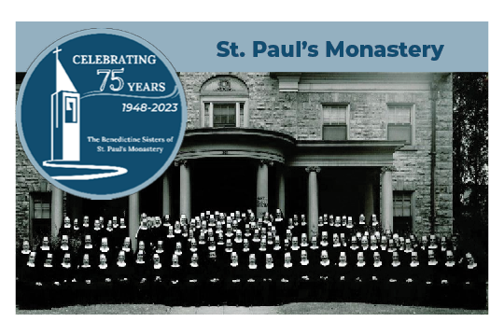

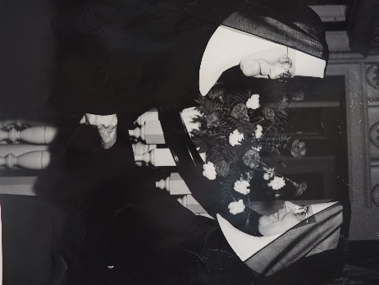
The anniversary of Founding Day is just around the corner. On June 22, 75 years ago, after the blessing of the new priory building and rooms, Mother Rosamond Pratschner, President of the Congregation read the erection decree and the election for the first prioress began. This was Sister Loraine Tracy (Mother Rosamond Pratschner is pictured here, congratulating Sister Loraine Tracy). Many changes occurred since that day to bring us to the present, including a brand-new building located in Maplewood with groundbreaking, 15 years ago in 2008. The Monastery will celebrate many milestones throughout this year. Please join the Sisters for these events!

Benedictine Festival | Saturday, June 24 12:00-3:00pm
Community event with Potter’s Pasties, Nelson’s Ice Cream, Mike’s Mini-Donuts, Bingo, raffle, and music by Patty and the Buttons on the grounds of the Monastery

Pilgrimage through the Priory Preserve | Saturday, July 8, 8:00-11:00am
Register to prayerfully walk the 1.5 mile trail (through the Priory Preserve created out of the former property of St. Paul’s Monastery) honoring the gift of creation

40th Anniversary of the Benedictine Center | Tuesday, August 15, 5:00-7:30pm
Celebrate the founding of the Sisters’ Benedictine Center and view the Monastery Invitational Art Exhibit highlighting Benedictine Values.

2nd Annual Blessing of the Animals | Sunday, October 1, 1:00pm
Pets and their human companions are invited to the beautiful grounds of the Monastery for a blessing of pets and celebration of the Feast of St. Francis.

All Souls Day Celebration & Blessing of Commemorative Pavers | Thursday, November 2, 5:00-7:30pm
Join the Sisters in honoring all the faithful departed, especially the deceased Sisters of the Monastery. New paver bricks will be blessed by the community (new pavers may be purchased on the Monastery website).

16th Annual Christmas at the Monastery | December 2-9
A week-long celebration including an Advent Retreat, wine education event, St. Nicholas Day fundraiser, wine and cheese evening with the Sisters, and an online silent auction.

Volunteers are sought to help make each of these events a success. Contact Jason Wittak at jwittak@stpaulsmonastery.org or 651-777-8181, ext. 409. View current volunteer opportunities at https://www.stpaulsmonastery.org/volunteer.

Sponsors are essential to empowering the mission of the Sisters. Contact Travis Salisbury at tsalisbury@stpaulsmonastery.org or 651-777-8181, ext. 403 to make sponsorship gift or a donation to support these events.

Stay connected to the Sisters! Sign up for the monthly E-Newsletter online at www.stpaulsmonastery.org and follow the Sisters on Facebook, Instagram, Twitter, YouTube, LinkedIn, and NextDoor.

